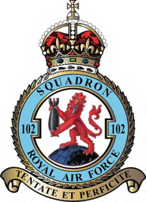
102 (Ceylon) Squadron Association.

Membership Renewal/Application 2026/27

Please return to:

Harry Bartlett. Chairman.,

25 Horndean Avenue, Wigston, Leicestershire, LE18 1DP

Tel 0116 2129996, email:102squadronassociation@gmail.com

Your Name
Your connection to 102 Squadron. (Dates served, rank or relative’s name.)
Full Address:  (or contact address) | Would you prefer correspondence and the newsletter by the internet or by post? Email/Post Yes/No
County:and Post Code
Phone Number:
Email Address:
Other Information:

I would like to APPLY/RENEW to be a member. Please find enclosed my
subscription of £ …… (Min £10.00) – due on the 28th February 2026
Payment can be made by Cheque payable to: 102 (Ceylon) Squadron Association
Bank Transfer: Lloyds Bank Sort Code 30 90 09 Acc. No. 58698560 102(Ceylon)Squadron Association (Please put your surname as the reference)
GDPR: Your personal data will not be shared with third parties without your express consent. If you no longer want your personal data held in our database, please advise the Chairman or Secretary in writing.

Signed…………………………………………. Date……………………

